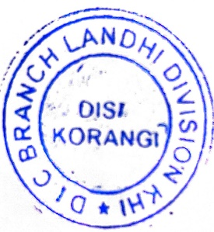
TECHNICAL ASSISTANCE REQUEST FORM FOR THE PROVISION DATA
(SSP KORANGI (DIC BRANCH) E-MAIL I.D: - diclandhi1@gmail.com)
Request No ……………. SP Landhi District Korangi, Karachi
FIR NO | U/S | DATED
CASE REF: CASE NO 1523/2024 PS KORANGI CASE |  | 17-09-2026
REQUIREMENTS
S.No | Cell Phone Number  IMEI Number | Required Information  (CDR, Registration Details, IMEI Search.  NADRA record, Cell Location) | Period of Information  (Dates)
01 |  | Searc | FROM 30-11-2025  TO DATE
UNDERTAKING
As a in charge, i am fully aware regarding the sanctity, security and integrity of the requisitioned Cellular Data and would never manipulate misuse and exploit any sort of Cellular Data for the vested interests. Further, I will remain caution & responsible for the safe handling Cellular Data and would not produce the same in any Court of Law as part of Prosecution Proceeding etc. Further, will be remain bound down myself & staff (PS) to obey all the direction and SOP, (If) issued by the worthy DIGP office & IB SPHQ.
Following documents must be enclosed with this Performa.

Attached
1- S.S.P Letter & | Yes ( ) No ( )
2- Copy of FIR & UNDERTAKING | Yes ( ) No ( )
3- Current Progress Repost / Status of the Case | Yes ( ) No ( )
FOR OFFICE ONLY USED.
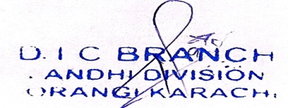
Name of Incharge : _______________
Name of INCHARGE Signature / Stamp :
Remarks

